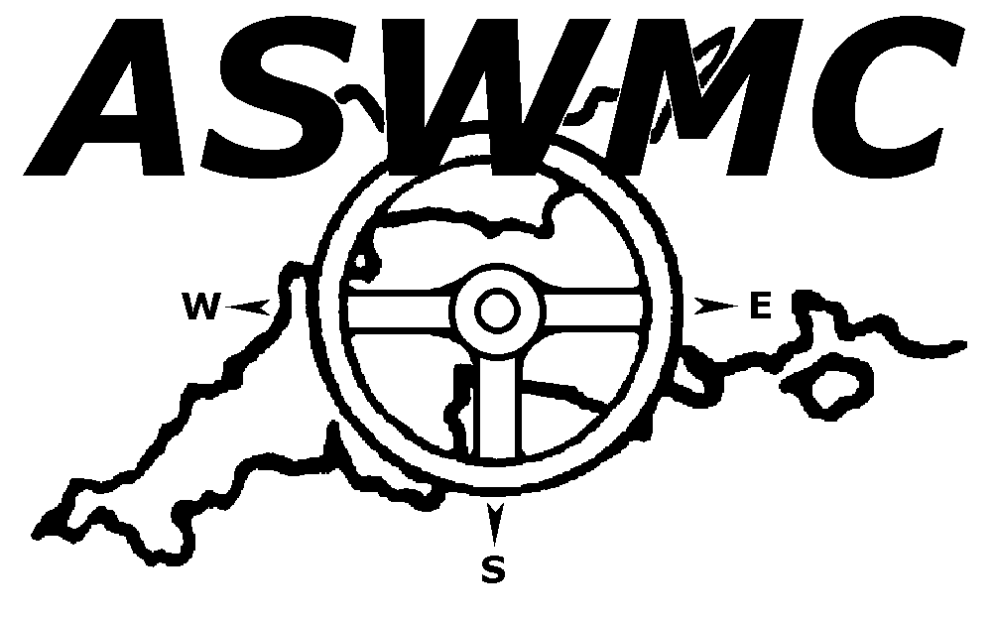

LAUNCESTON AND NORTH CORNWALL MOTOR CLUB LTD

Date Sunday 21st November 2021 Title of Event Ron Beer Sporting Trial

Name …………………………………………………………….. Club …………………………………………………………………...
Membership Number ……………………………………………..
Address ..……………………………………………………......... Passenger Club ……………………………………………………
Membership Number ……………………………………………..
………………………………………………………….…………. ASWMC Contender YES / NO

………………………………Postcode …………………………. M.S.UK RS Clubman License number ………………………………
Passenger MS UK RS Clubman License number ……………………
‘Phone – Home …………………………………………………... Class ………………………….……………………………………...

Work …………………………………………………... RED IND 1
RED LIVE 2
Passenger’s name ………………………………………………… BLUE IND 3
BLUE LIVE 4
Address ..……………………………………………………......... GREEN 5
POST HISTORICAL 6
………………………………………………………….………….

………………………………Postcode …………………………. Capacity ………………………………......……………………c.c

Car Type ………………………………………………………….. PLEASE COMPLETE ALL SECTIONS

INDEMNIFICATION & DECLARATIONS.
Held under the General Regulations of Motor Sport UK (incorporating the provisions of the International Sporting Code of the FIA)
hereafter referred to as the MS UK.

I declare that I have been given the opportunity to read the General Regulations of the MS UK and the Supplementary Regulations
for this event and agree to be bound by them.

I declare that I am physically and mentally fit to take part in the event and I am competent to do so. I acknowledge that I understand the
nature and type of competition and the potential risk inherent with motor sport and agree to accept that risk.

Further, I understand that all persons having any connection with the promotion and/or organization and/or conduct of the event are
insured against loss or injury caused through their negligence.

I declare that my car is fitted with a free and uninterrupted differential and no limited slip device is fitted.

My age is ……………………………………………………………. (if applicable, state ‘over 17 years’)

Entry Fee ………£35.00..............………….....………………………………………

Annual Membership Fee (if appropriate £10) …………………................…….…….…………………………………...

Passenger Membership (£1)) ................………………...................……………………………………...

Total ……………………………………………………………………………..

Cheques should be made payable to Launceston & North Cornwall Motor Club Ltd.
Please return to Pam Wevill The Manor House Lifton Devon PL160BJ [01566784451] j.wevill@btinternet.com
Fully completed &signed including passenger also.
Entries close on `17th November 2021 &no entries on the day

Driver’s Signature ………………………………………………………… Age if under 18 …………………….

Passenger’s signature …………………………………………………….. Age if under 18 …………………….

If the driver or passenger is under 18 years of age, the Parent/guardian must read and sign the following declaration and sign.

Note Where the Parent/Guardian/Guarantor is not present there must be a representative who must produce a written
and signed authorisation to so act from the Parent/Guardian/Guarantor.

Please complete below if driver or passenger is under 18 years.

Parent/Guardian Declaration and Agreement: To allow the applicant to enter the competition you must agree to the matters set out
below which are designed to create legal obligations on you. Sign below only if you agree.
- by the applicant and confirm the answers are true.
- event and that any vehicle which he/she will use is safe and fit for the competition
- myself that the course and facilities are safe and will inspect same.
- sustain any injury from any cause whilst taking part in the event and as a result bring a claim for compensation against you
or the organisers or officials or sponsors or entrants or owners of the venue
I WILL INDEMNIFY AND PAY BACK TO YOU any such which you may be required to pay as a result of such claim.

THIS ENTRY IS MADE WITH MY CONSENT,

Name of PARENT or GUARDIAN of DRIVER or PASSENGER *

……………………………………………..…………………………………………………………………………………………………..

Address…………………………………………………………………………………………………………………………………………

…………………………………………………………………. Postcode ……………………………………………………………………

* Delete as appropriate.

Signature of Parent or Guardian ……………………………………………………………………………………………………………….

****************************************************************************************************************

Emergency Contact: Driver, please contact ……………………………………………………......

On ………………………………………………………………………….

Passenger, please contact …………………………………………………….

On ……………………………………………………………

…I HEREBY CONSENT TO THE CLUB RETAINING DATA FOR INTERNAL ADMINISTRATION PURPOSES.

FULL PRIVACY POLICY IS SET OUT ON THE WEBSITE. PLEASE TICK BOX ………….

