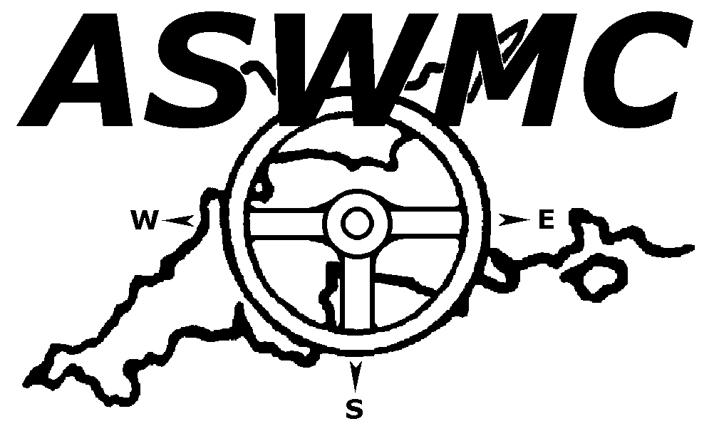

LAUNCESTON AND NORTH CORNWALL MOTOR CLUB LTD

MOTOR TRADERS CAR TRIAL SUNDAY 9th JULY 2017

ENTRY FORM

Drivers Name……………………………………………………………………………………………………

Address ……………………………………………………………………………………………………

……………………………………………………………………………………………………

Post Code ……………………………..

E-mail address …………………………………………………………………………………………..
(For final instructions and results)

Telephone No ……………………………………………………………

Club ………………………………………………………………………………….

Passengers Name…………………………………………………………………………………………….

Address ………………………………………………………………………………………………….

…………………………………………………………………………………………………...

Post Code ……………………………

Vehicle Make and Model…………………………………………………………………………………………..

Engine Capacity (cc)………………………………… Class Entered (see regs) ……………………………….

Double Drive? (Please state Yes or No) ………………………………………………………………………………

Emergency Contacts:

For Driver ……………….………………………………………………………………………..

For Passenger ……………….………………………………………………………………….

Entry Fee: £15 (per competitor) (under 16 £8)
Membership: (if required) £10

Total: _____

Cheques should be made payable to Launceston & North Cornwall Motor Club Ltd.

PLEASE READ AND SIGN INDEMNITIES AND DECLARATION OVER THE PAGE.

INDEMNIFICATION & DECLARATIONS

Held under the General Regulations of British Motor Sports Association Ltd (incorporating the provisions of the International Sporting Code of the FIA) hereafter referred to as the MSA.

I declare that I have been given the opportunity to read the General Regulations of the Motor Sports Association and the Supplementary Regulations for this event and agree to be bound by them.

I declare that I am physically and mentally fit to take part in the event and I am competent to do so. I acknowledge that I understand the nature and type of competition and the potential risk inherent with motor sport and agree to accept that risk.

Further, I understand that all persons having any connection with the promotion and/or organization and/or conduct of the event are insured against loss or injury caused through their negligence.

I declare that my car is fitted with a free and uninterrupted differential and no limited slip device is fitted.

Driver’s Signature………………………………………………………………... Age if under 18………………………

Passenger’s signature…………………………………………………………… Age if under 18………………………

Please complete below if driver or passenger is under 18 years.

As the Parent/Guardian of the driver/passenger, I understand that I shall have the right to be present during any procedure being carried out under the Supplementary Regulations issued for this event and the General Regulations of the M.S.A.

As the Parent/Guardian, I confirm that I have acquainted myself with the M.S.A. General Regulations, agree to pay any appropriate charges and fees pursuant to these regulations and hereby agree to be bound by those Regulations and submit myself without reserve to the consequences resulting from those Regulations. Further, I agree to pay as liquidated damages any fines imposed upon me up to the maxima set out in Part 3 Appendix 1.

THIS ENTRY IS MADE WITH MY CONSENT,

Name of PARENT or GUARDIAN of DRIVER or PASSENGER*

………………………………………………………………………………………………………………………..

Address…………………………………………………………………………………………………………..

………………………………………………………………………………………………………………………..

Postcode…………………………………………………………….

*Delete as appropriate.

Signature of Parent or Guardian……………………………………………………………………

*******************************************

Complete all relevant sections and post with entry fee to:

Pat Gomm, Newhaven, Darkey Lane, Lifton, Devon, PL16 0DY

Telephone 01566 784348

